**Urban and Rural Traffic Trends on Interstate 84 in Idaho: A Comparative Analysis**

Chris Felt

**Abstract**

In this paper, I compare average daily traffic for urban and rural areas along Interstate 84 (I-84) in Idaho. In particular, I investigate the difference in average daily traffic for four sites. Two sites, Site 1 and Site 2, are urban and are located near Boise, the largest population center in Idaho. The other two sites, Site 3 and Site 4, are rural and located near Twin Falls and Declo respectfully. This research uses data from the Idaho Transportation Department’s (ITD) automatic traffic recorders (ATR) website and its Average Annual Daily Traffic (AADT) shapefile. Analysis of this data shows that Site 1, Site 2 and Site 4 have upward trends in daily traffic. Site 3’s trend line is flat up to 2012 and then inclines indicating an increase in daily traffic. Projections for each site suggests that daily traffic at Site 1, Site 2 and Site 4 will continue to increase.

**Introduction**

In this paper, I investigate the differences in average daily traffic between urban and rural areas. In particular, I compare four sites along Interstate 84 (I-84). To examine the differences between the sites, I use data from the Idaho Transportation Department (IDT). The data I used includes average daily traffic measured by automatic traffic recorders (ATR). I also used IDT Average Annual Daily Traffic (AADT) data. In my analysis, I examine the differences between the sites using descriptive statistics and I use seasonal ARIMA models to forecast traffic trends for each site. The paper is separated into two sections. In the first section, I discuss the characteristics of each site. In the second section, I discuss the data and my analysis.

***Study Area***

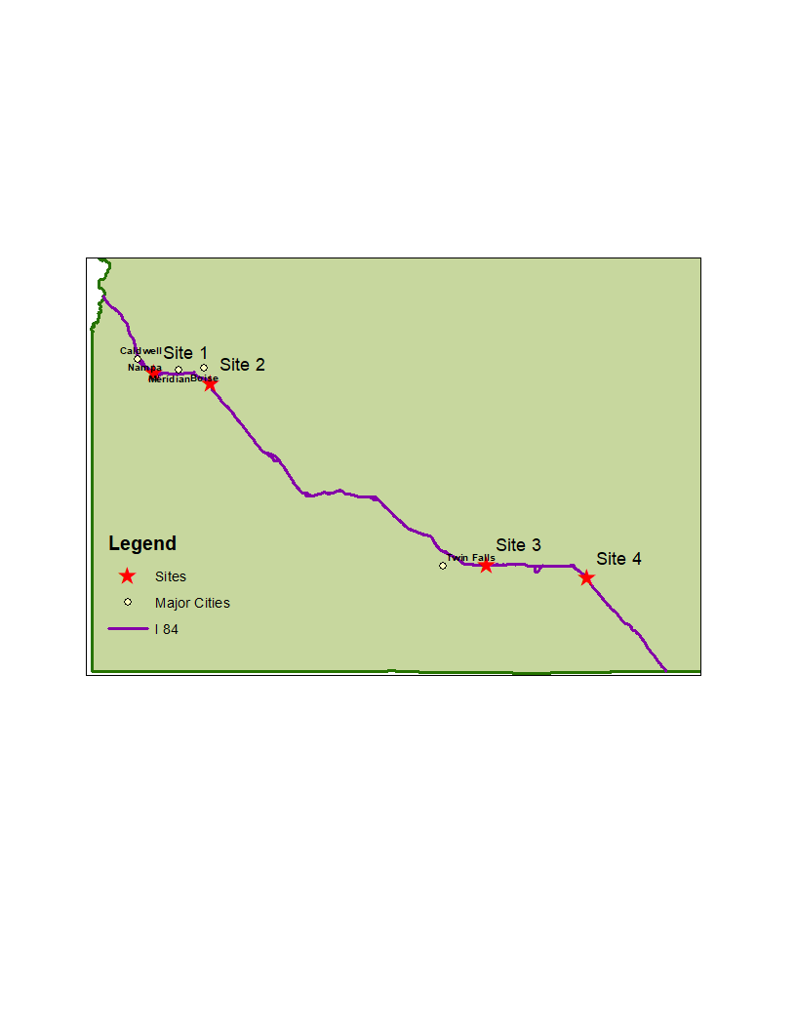

**Map 1: Location of Sites along Interstate 84**

I chose four sites for the present comparative analysis. I chose the sites based on a set of criteria. The first criterion is completeness of the data. I examined each dataset related to an ATR along the I-84. The chosen ATR datasets are the most complete. In addition to having the most complete datasets, the chosen sites also have corresponding data in the AADT shapefile. Other sites possess nearly complete ATR datasets but do not have any corresponding data in the AADT shapefile. These datasets are not included in the following analysis. The second criterion is location. In addition to having the most complete data, the sites are located at points along the I-84 that allow for a comparison of traffic behavior between urban and rural areas.

Site 1 and Site 2 represent the urban sites in the present analysis. Site 1 is located at mile point 32.4, which is located within the Nampa urban area (COMPASS 2014). The population of the Nampa urban area in 2012 is approximately 81,900 and 86,000 in 2016 (US Census 2016, US Census 2012). The area that falls within one mile of this site is largely consider medium density developed area (Homer et al 2011). Industry constitutes 2.46 square miles of this immediate area and is the primary land use type. Residential and commercial are the next prominent land use types constituting 1.59 and 1.38 square miles respectfully (COMPASS 2014). Site 2 is located at mile point 58, which is located near the southeast side of the Boise urban area. The population of the Boise urban area is approximately 278,672 in 2012 and 293,502 in 2016 (US Census 2016, US Census 2012). The area that falls within one mile of this site is largely undeveloped shrubland and grassland (Homer et al 2011). The primary land use type by a large margin is public land and it constitutes 21 square miles of the surrounding area (COMPASS 2014). Residential land use constitutes the immediate area that lies within the Boise urban area.

The rural sites in the present analysis are Site 3 and Site 4. Site 3 is located at mile point 186.3, which is roughly 15 miles northeast of Twin Falls. Agriculture surrounds this site except for the very small urban areas of Eden and Hazelton to the north. The population of each urban area has remained less than 1000 from 2012 to 2016 (US Census 2016, US Census 2012). Production of four primary agriculture products occur within five miles of Site 3. From the 2007 to 2017, the primary agriculture products include alfalfa, barley, potatoes and sugar beets (Han et al 2014).Site 4 is located at mile point 227, which is roughly 40 miles north of the Utah border. The closest urban area is Declo, which is roughly 10 miles away. Although there is agriculture nearby, much of the surrounding land cover is undeveloped shrubland and grassland (Homer et al 2011).

**Analysis**

***Data***

The data used for the following analysis I collected from two sources. First, I used data collected by the ITD ATRs (Idaho Transportation Department 2018a). The ATRs measure the average daily traffic for each month. There are several recorders along the I-84 and the data spans from 1990 to 2012. However, not every recorder has complete data available. Many of the datasets for the recorder are missing months or whole years. As mentioned above, the sites I chose have the most complete data. Although the data used for this analysis is the most complete, the data does have missing values. I filled the missing values in the dataset with the next valid observation. Although this method of handling missing data adds a small degree of inaccuracy to the data, it is not substantial and does not affect the following analysis.

The second data source used is the AADT. I derived the data from the ITD AADT shapefile (Idaho Transportation Department 2018b). This data is a measure of the average daily traffic for entire year for the years from 1999 to 2016. This data is not as precise as the ATR data. However, it provides adequate and relatively recent data. Additionally, AADT and ATR do not measure the exact same points along the I-84. However, they record roughly the same area, which is adequate for comparison.

***Descriptive Statistics***

This section examines the data for each site in detail. For each site, I calculate a simple moving average and standard deviation. After that, I use a method called seasonal decomposition. This method uses moving averages to calculate and separate the trend in the data as well as the seasonality and any remaining noise in the data. Finally, I end this section with an analysis of the AADT data for each site.

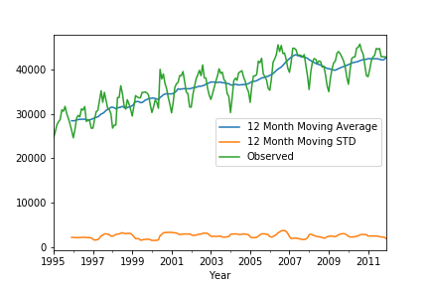

**Figure 1: Observed data, 12-month moving average and 12-month standard deviation (STD) for Site 1 traffic data from 1995 to 2012**

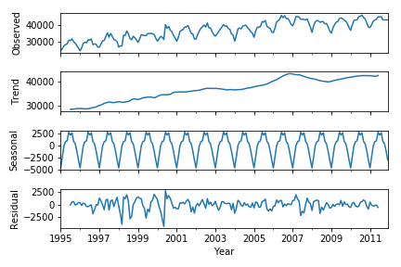

**Figure 2: Observed data, trend line, seasonal trend and residual noise in Site 1 traffic data from 1995 to 2012**

Figure 1 above shows the observed data for the first site as well as a 12-month moving average and a 12-month moving standard deviation. What is immediately apparent in the observed data is the seasonality. The cyclical behavior of the observed data line depicts the seasonality of the data. The behavior of the line is seasonal rather than cyclical because the cycles correspond to the time of the year with the winter months experiencing less traffic than the summer months. The seasonal graph in Figure 2 indicates the amount of change that occurs in each cycle. This graph shows that during the winter months, the amount of traffic drops roughly 2500 vehicles below the mean during the winter months. During the summer, traffic increases 2500 vehicles above the mean. This totals to a 5000-vehicle difference in daily traffic between the winter and summer months.

Next, the trend in the data shows that the amount of daily traffic at Site 1 has increased to over 12,000 vehicles per day over that last fifteen years from roughly 28,000 vehicles to roughly 42,000 vehicles. There is a dip in this number after 2007. After that, the trends continues to increase.

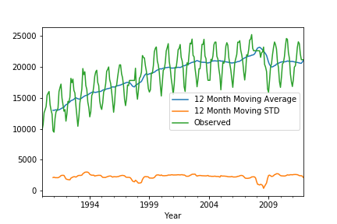

**Figure 3: Observed data, 12-month moving average and 12-month standard deviation (STD) for Site 2 from 1990 to 2012**

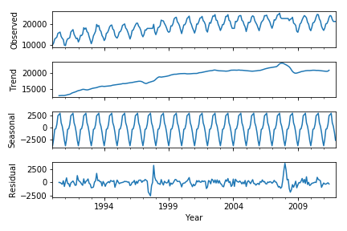

**Figure 4: Observed data, trend line, seasonal trend and residual noise in Site 2 traffic data from 1990 to 2012**

Figure 3 and Figure 4 show similar behavior to that of the Figure 1 and Figure 2. As with Site 1, Figure 3 shows the seasonality of the traffic with the annual change from low to high points. This similarity extends to the amount of change between the winter and summer month which is a 5000 vehicle difference in daily traffic. Another common trait between the two sites is the upward trend in traffic. In fact, the amount of traffic seems to have increased the same amount, which is equal to roughly 12,000 vehicles.

Although the two sites are very similar in terms of their seasonality and their upward trends, they do differ in the total amount of daily traffic. For instance, Site 1’s highest point is in 2007 with 42,000 vehicles. Site 2’s highest point is roughly at the same period but its average daily traffic is approximately 22,000 vehicles. The location of the sites can possibly contribute to the difference. Although both sites are within or near an urban area, Site 1 is among a variety of land use types that could contribute to its higher daily traffic. For instance, shipments and customer patronage to the surrounding industry and commercial locations can increase the amount of daily traffic. Additionally, Site 1 could also be capturing commuter traffic headed toward the surrounding residential area. Site 2 is also near some residential area but the area is smaller than Site 1.

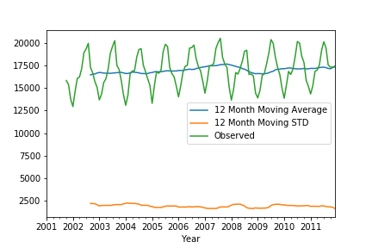

**Figure 5: Observed data, 12-month moving average and 12-month standard deviation (STD) for Site 3 traffic data from 2001 to 2012**

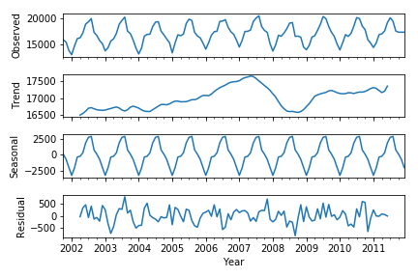

**Figure 6: Observed data, trend line, seasonal trend and residual noise in Site 3 traffic data from 2001 to 2012**

Figures 5 and 6 show the descriptive statistics for Site 3. Figure 5 shows that the traffic for this area is similar to the urban sites. The similarities rest in the seasonality of the data and the amount of difference between the winter and summer month. However, unlike the urban sites, Site 3 does not appear to have an upward trend. Additionally, the total amount of daily traffic does not rise above 17,500 vehicles for a roughly ten-year span.

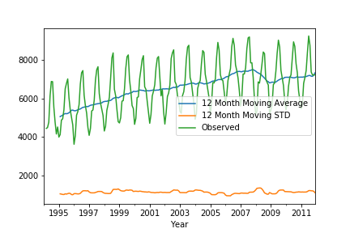

**Figure 7: Observed data, 12-month moving average and 12-month standard deviation (STD) for Site 4 traffic data from 1994 to 2012**

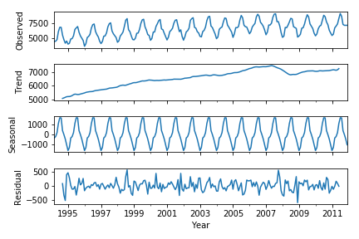

**Figure 8: Observed data, trend line, seasonal trend and residual noise in Site 4 traffic data for the years from 1994 to 2012**

Figures 7 and 8 show that Site 4 shares more similarities with the urban sites than the other rural site. Site 4 is similar to all sites because of the seasonality of the data. Site 4 is similar to the urban site because of the upward trend in the average daily traffic. However, this is only a 2,000 daily traffic increase. Site 4 differs from the rest in terms of total average daily traffic, which just barely rises above 7,500 vehicles.

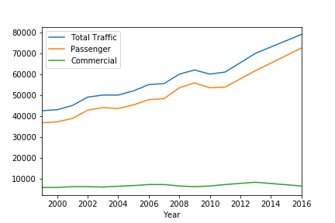

**Figure 9: Average annual daily traffic at Site 1 for the years from 1999 to 2016**

Figures 9 – 12 show the AADT for each site respectfully. Figure 9 shows the AADT for Site 1. There are several telling characteristics about this figure. First, the total daily traffic for Site 1 has an upward trend. This upward trend is similar to the findings in Figure 1. Second, as time increases, passenger traffic becomes an increasingly larger portion of the total daily traffic. Commercial traffic, on the other hand, remains at a constant level below 10000 vehicles per day. This result corroborates the notion that the ATR at the Site 1 location is capturing commuter traffic that is destined for the surrounding residential area. Additionally, this decreasing percentage of commercial traffic that makes up total traffic suggest that industry may be gradually losing prominence as a land use type in the area. For instance, the increase in passenger traffic may be indicative of a shift in the area from industry to residential. As more development that is residential occurs in the area, less industrial development is occurring. This leads to a constant amount of commercial traffic becoming a smaller portion of total traffic.

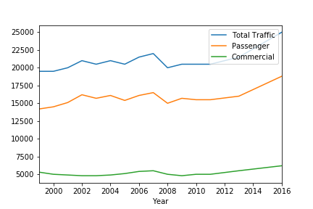

**Figure 10: Average annual daily traffic at Site 2 for the years from 1999 to 2016**

Figure 10 shows the AADT for Site 2. Although this site is considered urban like the previous site, it differs from it in two ways. First, passenger traffic makes a smaller portion of the total daily traffic. This observation along with the relatively small amount of residential area located near the ART suggests that residential is not increasing at an increasing rate. It also suggests that other lands use types may be competing for the same space in the area. The proportion of commercial traffic that holds for the period reinforces this idea. Additionally, the average traffic for Site 2 does have an upward trend. However, it is very slight. This behavior might suggest a lack of development in the area. This is a possibility given the high amount of public land that exists at that location.

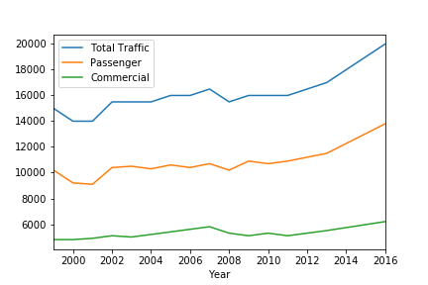

**Figure 11: Average annual daily traffic at Site 3 for the year 1999 to 2016**

Figure 11 and 12 show the AADT for the two rural sites, Site 3 and Site 4. Figure 11 shows the AADT for Site 3. One thing that is immediately noticeable in Figure 11 is that passenger traffic constitutes much less of the total daily traffic than the two urban sites. For instance, passenger traffic at Site 1 and Site 2 constitute roughly 90 percent and 75 percent, respectfully. At Site 3, passenger traffic is only roughly 60 percent. The most likely possibility is that there is not a substantial amount of commuter traffic to and from Twin Falls. This possibility seems especially likely given that many of the smaller nearby cities are located on highways, which remove the need to use I-84. Additionally, the trend in Figure 11 is relatively flat up to 2012. This trend matches the trend seen in Figure 5. However, after 2012, there is a slight increase from 16,000 to 20,000 from 2012 to 2016.

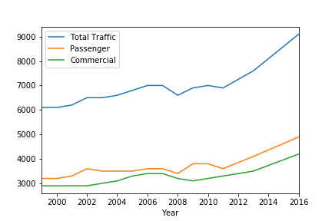

**Figure 12: Average annual daily traffic at Site 4 for the year 1999 to 2016**

Site 4 is the site that is the farthest from any urban area and the AADT at this site bears this characteristic out. The passenger traffic for this site is nearly equal to the commercial traffic. Finally, there is a slight trend to the data with an uptick in traffic from 2012 to 2016.

***Projections***

To model and forecast average daily traffic trends I used a seasonal ARIMA Model. To develop the data for use in the model, I used a first difference and seasonal difference for each dataset with exception of Site 3. For Site 3, I found that, after testing, a seasonal difference was sufficient. To check for the stationarity of the data I used an augmented Dicky-Fuller test. The test indicated that each dataset is stationary at the .01 level. After that, I plotted the autocorrelation and partial autocorrelation for each dataset. Based on this analysis, I constructed different models and determined the best fitting model using the Akaike information criterion. The models that proved to be the best fit I used to create the following projections.

Each of the following plots show the observed data for each site as well as the rough projection of average daily traffic for eight years. An eight-year forecast horizon creates a projection that goes beyond the scope of the AADT data. This forecast horizon makes it possible to compare the AADT and projections as well as consider the possible average daily traffic in the future. Each projection is a very rough estimate but offer a general direction of future traffic trends.

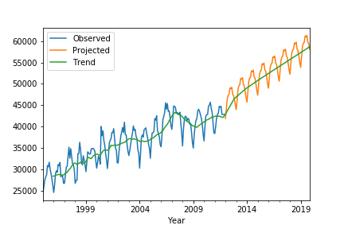

**Figure 13: Observed and projected average daily traffic trends for Site 1**

Figure 13 depicts the traffic projections for the first urban site, Site 1. The ARIMA model that this projection is based uses a moving average term, a seasonal autoregressive term and a seasonal moving average term along with the differencing mentioned above. This projection suggests that the upward trend will continue and daily traffic will continue to increase. This upward trend is corroborated by Figure 9 which shows a continued incline in daily traffic from 2012 to 2016.

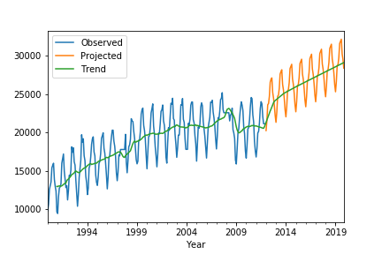

**Figure 14: Observed and projected average daily traffic trends for Site 2**

Figure 14 shows the projection for the other urban site, Site 2. This projection is a based on similar ARIMA model as the previous projection. As with the previous projection, this shows a continue upward trend in daily traffic. This trend is supported by the AADT data for Site 2. In fact, Figure 10 and Figure 14 nearly match for the year of 2016. Both figure indicate a roughly 25,000 daily traffic average.

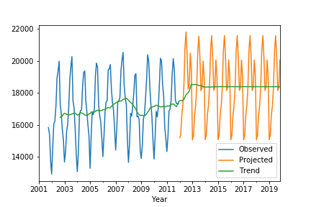

**Figure 15: Observed and projected average daily traffic trends for Site 3**

Figure 15 shows the projected average daily traffic for Site 3. Unlike the two previous projections, the ARIMA model used for this projection includes only a seasonal difference. The results of the model suggest that traffic at Site 3 will have a constant flow of traffic from 2012 to 2019. However, this projection is not supported by the AADT data for this site. Figure 11 shows that after 2012, average daily traffic increases slightly.

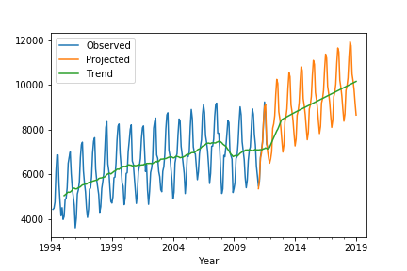

**Figure 16: Observed and projected average daily traffic trends for Site 4**

The last figure shows the projection for Site 4. These projections are based on a similar ARIMA model to the two urban projections. Figure 16 shows that the site will continue its upward trend. This projection is supported by the AADT data for this site. Figure 12 and Figure 16 both show average daily traffic crossing the 9,000 mark roughly around 2016.

**Conclusion**

In this paper, I examined four sites. Site 1 and Site 2 are the urban sites. Site 1 is located within Nampa. Industry, residential and commercial are the prominent land use types that surround the site. Site 1 experienced the highest amount of traffic for entire period. Passenger vehicles constituted most of this traffic. Projections suggest that daily traffic will continue to increase for this site. Site 2 is located on the southeast side of Boise. Publicly owned land covered with shrubs and grass primarily surround Site 2. This site experienced the second highest amount of traffic for the period. Most of the traffic is passenger but constitutes a smaller portion of total traffic compared to the previous site. Projections suggest that daily traffic will increase, however, at a lower rate than the previous site. Site 3 and Site 4 are the rural sites. Site 3 is located near Twin Falls and surrounded by agriculture. The average daily traffic is substantially less than the two urban sites and the trend is flat. The area is not projected to experience an increase in traffic. However, this projection is not supported by AADT data. Finally, Site 4 is located 10 miles from Declo and 40 miles north of Utah. This site experienced the lowest amount of traffic and the number passenger vehicles is roughly equal to the number of commercial vehicles. Traffic in this area is very low but projections suggest that it will continue to increase.

**References**

COMPASS (Community Planning Association of Southwest Idaho) (2014) Working together to plan for the future project. http://www.compassidaho.org/documents/planning/studies/Final TVReport-GrowthScenarioAnalysis.pdf. Accessed 24 September 2014

Han W, Yang Z, Di L, Yue P (2014). A geospatial Web service approach for creating on-demand Cropland Data Layer thematic maps. Transactions of the ASABE 57: 239-247

Homer C G, Dewitz, J A, Yang L, Jin S, Danielson P, Xian, G, Coulston J, Herold N D , Wickham J D, Megown K, (2015)  [Completion of the 2011 National Land Cover Database for the conterminous United States-Representing a decade of land cover change information](http://bit.ly/1K7WjO3). Photogramm Eng and Remote Sens 81: 345-354

Idaho Department of Lands (2018) Interstate 84 ATR. [Text Files]. <http://apps.itd.idaho.gov/apps//roadwaydata/Maps/ATR_I84_map.html>

Idaho Department of Lands (2018) AADT 1999 – 2016. [Shapefile]. https://www.arcgis.com/home/item.html?id=aa62e9e66823421f9f6e51d1039b0943

U.S. Census Bureau, Population Division (2016) Annual Estimates of the Residential Populating for Selected Age Groups by Sex[Data File]. https://factfinder.census.gov/faces/tableservices/jsf/pages/productview.xhtml?pid=PEP_2011_PEPAGESEX&prodType=table. Accessed 20 March 2017

U.S. Census Bureau, Population Division (2012) Annual Estimates of the Residential Populating for Selected Age Groups by Sex[Data File]. https://factfinder.census.gov/faces/tableservices/jsf/pages/productview.xhtml?pid=PEP_2011_PEPAGESEX&prodType=table. Accessed 20 March 2017